Ideas for Maximizing Media Exposure and Public Engagement
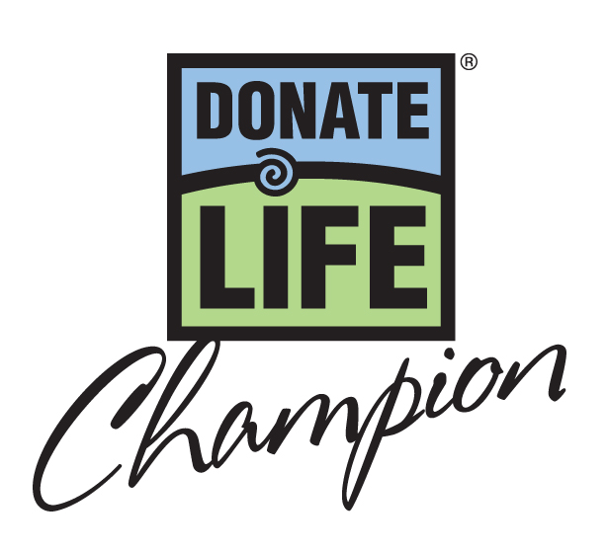

Before submitting nomination form(s)
- During the summer, solicit pre-nominations for Donate Life Champions from retired and current athletes and coaches in the community. (They will be future supporters to help promote the person/team receiving the award.)
- Consider pre-nominations for Champions being submitted (to your State Team) by the public either through your website or Facebook Page, or the website/FB Page of a local sports program. Pick your favorite(s) of the pre-nominees and submit them to the DL Champions committee as your state’s nominees.
- Give a shout out to potential nominees on Facebook and Twitter, or at a press event with local athletes there to promote the award.
- If you are comfortable with it, consider letting the community vote for nominee(s), a la “American Idol. If you do so, then poll your community sports organizations, transplant centers, colleges and universities. Identify nominees who the community would like to honor, THEN put it out in the public realm to narrow the list down through voting, which will create buzz.
- Google “organ donation” with the names of all local teams and athletes to find connections to donation/transplant.
- Name some high profile people as co-chairs of the local Donate Life Champion campaign. For a similar event in San Diego, the John Brockington Foundation had Bill Walton (retired NBA) and Randy Jones (retired MLB) serve as honorary co-chairs and they spoke at press conferences and recorded PSAs (video and audio).

After the award recipient(s) have been determined
- Be clear with media outlets why they will want to be at the award presentation (use media alert/tip sheet with a few quick facts).
- Audio PSAs are inexpensive and, if kept to 30 seconds and recorded by local coaches or professional athletes, can be very effective.
- Create a sense of local pride in honoring the award recipient. As an example, the John Brockington Foundation’s PSAs consistently ended with statements like “I am Bill Walton, I am a proud San Diegan, but more importantly, I am a FanForLife.”
- Plant a news item in the newspaper’s sports page, ghost-written on behalf of a local coach or athlete with a connection to the award recipient (or who IS the award recipient). Then make sure the newspaper receives a press release about the Donate Life Champion award.
- Have the City Council or Mayor declare the day of presentation “FanForLife Day” through an official proclamation.
- Make certain everyone involved has talking points handy to really push your message.
- Showcase the visible icon for the campaign (foam finger graphic or DL Champions logo). Almost every document and social media message should include the graphic or logo. Provide it electronically to the media.
- Arrange to distribute Donate Life foam fingers at the award presentation and related events. People find them irresistible, they are inexpensive, and provide great visual aids for media coverage.
- Use the foam finger graphic as your Facebook Page profile picture the week of November 12-18, when the Donate Life Champion awards are being presented nationally.
- Team up with local Parks & Recreation Department social media sites to promote Donate Life Champions on their Facebook Pages, encouraging their followers to sign up on the Donor Registry to become a FanForLife.

Ideas for presenting the Donate Life Champion award
- Midnight Madness events for college basketball season kickoffs when awards go to college basketball related celebrities (typically happen in late October or early November)
- At the conclusion of College Campus Challenge events where athletes/coaches from schools receive awards
- At Booster Club events for universities (for example: Ram's Club for UNC or Iron Dukes for Duke)
- Halftime awards presentations for football, basketball or hockey events
- Create a Donate Life Champions and FanForLife theme for annual volunteer recognition events and present awards
- Campaign kick-off event for major outreach could include an awards ceremony with the Champion award winner and an educational program (for example, Durham hopes to bring Shaquille O'Neal in for a major outreach campaign targeted to the African-American community)
- Since most awards will be given post-national election, tie the presentation into the bipartisan nature of awards (this is an issue all parties can come together on) – host it on the Capitol grounds, and ask members of both major parties to co-present the Donate Life Champion award
- Many local youth athletic programs wrap up in November. Try to present the Donate Life Champion award at statewide tournaments as part of their tournament kick-off celebrations, when all teams and parents are present.
- If the award recipient is a high school athlete or team, tie in to the end-of-season awards with a big press event to announce "all-state/conference" selections (typically involves media coverage) and present the Donate Life Champion award

